

American International University-Bangladesh (AIUB)  
**Department of Computer Science  
Faculty of Science & Technology (FST)**

**Job Onushondhan**

A Software Requirement Engineering Project Submitted By

|  |  |  |  |  |
| --- | --- | --- | --- | --- |
| **Semester: Spring_22_23** | | **Section:** | **Group Number:** | |
| SN | Student Name | Student ID | Contribution (CO1+CO2) | Individual Marks |
| 1 | Annafi Bin Alam | 19-40258-1 |  |  |
| 2 | Moshfiqur Hasan | 19-40257-1 |  |  |
| 3 | Mostakim Bin Mokbul Rhythm | 19-40260-1 |  |  |
| 4 | Nayemul Basir Nahid | 19-39640-1 |  |  |
|  |  |  |  |  |

The project will be Evaluated for the following Course Outcomes

|  |  |  |
| --- | --- | --- |
| Evaluation Criteria | Total Marks (50) | |
|  | |
| Introduction, Format, Submission, Defense | [10 Marks] |  |
| System Overall Description & Functional Requirements | [10 Marks] |  |
| System Quality Attributes and Project Requirements | [10 Marks] |  |
| UML and E-R Diagram with Data Dictionary | [10 Marks] |  |
| UI/UX Prototyping | [10 Marks] |  |

Software Requirements Specification

for

Job Onushondhan

Version 1.0 approved

Prepared by

X organization ltd

29-4-2023

Table of Contents

Revision History 4

1. Introduction 4

1.1 Purpose 4

1.2 Document Conventions 4

1.3 Intended Audience and Reading Suggestions 5

1.4 References 5

2. Overall Description 5

2.1 Product Perspective 5

2.2 Product Functions 5

System Features: 5

2.3 User Classes and Characteristics 7

2.4 Operating Environment 8

2.5 Design and Implementation Constraints 8

3. System Requirements 9

3.1 System Features 9

3.2 Non-Functional/Quality Requirements 11

3.3 Project Requirements 12

1. The system developer needs selenium tools in perform testing activities. 12

2. The designer needs Figma to create more samples of the prototype. 12

3. The developers require computers with Windows OS. 12

4. Design and Interface Requirements 13

4.1 UML Diagrams 13

4.1.1 Use Case Diagram 13

4.1.2 ER Diagram 14

4.1.3 Class Diagram 15

4.1.4 Activity Diagram 16

4.2 Data Dictionary 17

4.3 UI/UX Design Specification 17

# Revision History

|  |  |  |  |
| --- | --- | --- | --- |
| **Name** | **Date** | **Reason for Changes** | **Version** |
|  |  |  |  |
|  |  |  |  |

# Introduction

## Purpose

One of the finest options for students looking to get some extra cash is a part-time job. The practice of taking on part-time work to supplement one's income is progressively gaining traction among Bangladeshi students. In addition to managing their pocket money, students who work part-time can help their families and pay for their education. Additionally, while working part-time employment, students can pick up knowledge and develop crucial skills like teamwork and team management. There are numerous job portals available in our nation, such as BD Jobs. However, this employment board mostly highlights full-time positions. Therefore, it can be challenging to obtain part-time work on these portals. The issue is that there is no dedicated job board for part-time employment. Students therefore encountered challenges in locating their ideal part-time work.

**Root cause of this problem and the importance to consider this problem**

The root cause of this problem is no one cares that much about part-time job. All types of job portals in Bangladesh are working for full time jobs.

This problem is so important to consider because nowadays doing part time jobs besides study is becoming trend among students. Different types of students have different types of working demand, like: some want to work as a volunteer, some want to do tuition, computer operator, research assistant and many more.

## Document Conventions

Requirements are pointed out with their priority, cross references and pre conditions.

The prototype is shown as a series of screenshots of the different pages.

## Intended Audience and Reading Suggestions

The following document is written for the:

* Developers- UML diagrams given below will assist in implementation.
* Testers- The functional and non-functional requirements will assist QA teams and testers.

The document should be read from Section 1. After Section 1, Section 2 is to be read and then the UML diagrams from Section 4. Then, the requirements should be understood from Section 3. Once the requirements from Section 3 are understood, the prototype is to be studied in Section 4.

## References

User Interface Design: **Figma** - https://www.figma.com/

# Overall Description

## Product Perspective

To address this issue, we will create a site for part-time employment. Additionally, this job board only highlights various kinds of part-time employment. Through this project, we can link employers and people looking for part-time work. where both employers and employees can readily submit jobs for employment. Our startup company only focuses on one industry, which is now quite popular, thus there is a great likelihood that we will be able to achieve our targeted business goal.

## Product Functions

# System Features:

This app will have the following specifications/features:

1. Signup feature

(Here user can give their Valid information like Name, Password, Email, Role Then Payment method for Registration and transaction number to sign up. So here we use some text box, combo box to design this module)

1. User Verification

(Here we send a verification number in email to verify the Customer or user)

1. Login Feature for Existing User

(Here user can log in the System using their Username and Password. Here we use Two box in design)

1. User profile

(Here user can see their All of given information. Here we use some CSS design to beautification for this page)

1. Profile info. Update

(Here user can Update any information if they need. They change their information and click the update button then all of the information will be changed)

1. Submit Resume/CV

(Here user can submit their CV or Resume. So here in option to select the file after select the file user can click the submit button then he can successfully upload her cv)

1. Post job

(Here Employer can add their job advertisement. there is an option to upload job notice or write job notice. after successfully doing all the work employer can click the submit button to submit. Then the Registered employee and other people can see the advertisement)

1. Apply job

(Here Employee can see the job advertisement. In each advertisement their will be a

option to apply. After clicking the apply the Application from will arrive and then the employees need to fill up the form and attach their cv.)

1. Rate Job

(There is an option to give feedback or Rate job)

1. Contact us

(Here we can use the website authorized email and phone number, Facebook Page Link and Other Social Media link if anybody want to contact us)

1. History of Job

(Here Employee and Employer Both can see how many people have applied for the job and how many people have find the job by the website. We will also provide the data of all jobs)

1. Log Out

(If they click this button they will be logged out of the website)

1. Account Deletion

(If any user wants to delete their Profile, they can use the option to delete their Account)

## User Classes and Characteristics

In our Job portal system, there will be two types of users

* Employer
* Employee

However, anyone can visit the page. if anyone wants to apply for a new job or make a new post for the job than he needs to fill up the registration from and this form will be verified by the system. After successful verification they will become registered employee and employer. Registered employees can additionally rate the job.

The system will show the statistical data and also the featured data in the homepage of the portal. All of the verification process will be done by the system.

## Operating Environment

**For server side:**

Components of the software system must operate within a Windows operating system environment.

**For client side**:

1. Web Browsers that must be supported –

Apple Safari 10+, Google Chrome 44+, Microsoft Internet Explorer 10+, Mozilla Firefox 40+

1. Mobile Operating Systems­ –

Android 12+, iOS 11+

## Design and Implementation Constraints

**Implementation**:

1. This software is to be developed in Microsoft Visual Studio, ASP.NET with C#, JSON, CSS, JavaScript, jQuery, HTML.
2. Two factor authentication must exist to ensure the security of sensitive information.
3. The back button must be on left side of page.
4. Password must be encrypted.
5. The site must have a translated version (Bangla).

**Design:**

1. All validation errors on profile and sign-up pages must be in Red and **Bold**.
2. The back button must be on left side of page.
3. All save and submit buttons must either be centered or placed on right.

# System Requirements

## System Features

**1. Login:**

**Functional Requirements (FRs)**

1.1 The system shall allow users to login with their registered user id and password

1.2 The login credentials (user id and password) will be verified with database record

1.3 If the login successful, the homepage of the user account will be displayed

1.4 If the user id or password has been inserted wrong, the verification code will be generated and sent to the user’s email address by the system to retry login

1.5 If the number of login attempt exceed its limit (5times), the system shall block the user account login for 30 minutes

Priority Level: High

Precondition: user have valid user Id and password

**2. Registration:**

**Functional Requirement (FRs)**

**2.1** The user can give their Valid information like user Id, password, email, address, number and transaction number to sign up.

**2.2** The user can give work experience, education and skills

**2.3** The user will set two-factor authentication code.

**3. User Verification**

**Functional Requirement (FRs)**

**3.1** Here we send a verification number in email to verify the customer or user

**Priority level: High**

**Precondition: User /Customer**

**4. User Profile**

**Functional Requirement (FRs)**

**4.1** The user can see their All of given information

**4.2** We use some CSS design to beautification for this page

**5. Login Feature for existing user**

**Functional Requirement (FRs)**

**5.1** The user can log in the System using their Username and Password. Here we use Two box in design

**6. Profile information update**

**Functional Requirement (FRs)**

**6.1** The user can Update any information if they need. They change their information and click the update button then all of the information will be changed

**7. Post Job:**

**Functional Requirement (FRs)**

**7.1** The Employer can add their job advertisement.

**7.2** There will be an option to upload job notice or write job notice. after successfully doing all the work employer can click the submit button to submit.

**7.3** Then the Registered employee and other people can see the advertisement

**8. Job search filters**

**Functional Requirement (FRs)**

**8.1** Once registered, users can search for jobs using various filters such as location, job title, salary range, industry, and type of employment (full-time, part-time, contract, etc.)

**9. Apply job**

**Functional Requirement (FRs)**

**9.1** The Employee can see the job advertisement.

**9.2** In each advertisement there will be an option to apply.

**9.3** After clicking the apply the Application from will arrive and then the employees need to fill up the form and attach their cv

**10. Job Alerts**

**Functional Requirement (FRs)**

**10.1** TheUsers can set up job alerts to receive notifications about new job postings that match their search criteria

**11. Contact Us:**

**Functional Requirement (FRs)**

**11.1** We can use the website authorized email and phone number, Facebook Page Link and other Social Media link if anybody want to contact us

**12. Logout**

**Functional Requirement (FRs)**

**12.1** If they click this button they will be logged out of the website

**13. Account Deletion**

**Functional Requirement (FRs)**

**13.1** If any user wants to delete their Profile, they can use the option to delete their Account

**Priority Level:** High **Precondition:** user have valid user id and password

## Non-Functional/Quality Requirements

**QA1: Performance:** A trained user shall be able to create a profile within 3 minutes. Search bar results (up to 8 items) will be available within 1 minute.

**Priority Level: Medium  
Precondition: Application is run on supported OS**

**QA2: Safety:** A past copy of the database, which was backed up to the archives, is restored upon extensive damage to the database due to any attack or accident.

**Priority Level: High  
Precondition: Back up is uploaded after regular time periods**

**QA3: Reliability:** It is ensured that the features of the software lead to the correct functionalities. It is also ensured that the software is available throughout the day.

**Priority Level: High  
Precondition: None**

**QA4: Usability:** The software contains user friendly aesthetics making for a satisfying and pleasing experience. The features are present right where they are expected making the software very intuitional.

**Priority Level: Medium  
Precondition: None**

**Q5: Scalability:** The software is capable of handling increased load (number of requests and applications) without decreasing its performance.

**Priority Level: Medium  
Precondition: Application is run on supported OS.**

## Project Requirements

**Tools:**

# The system developer needs selenium tools in perform testing activities.

# The designer needs Figma to create more samples of the prototype.

# The developers require computers with Windows OS.

# Design and Interface Requirements

## UML Diagrams

### Use Case Diagram

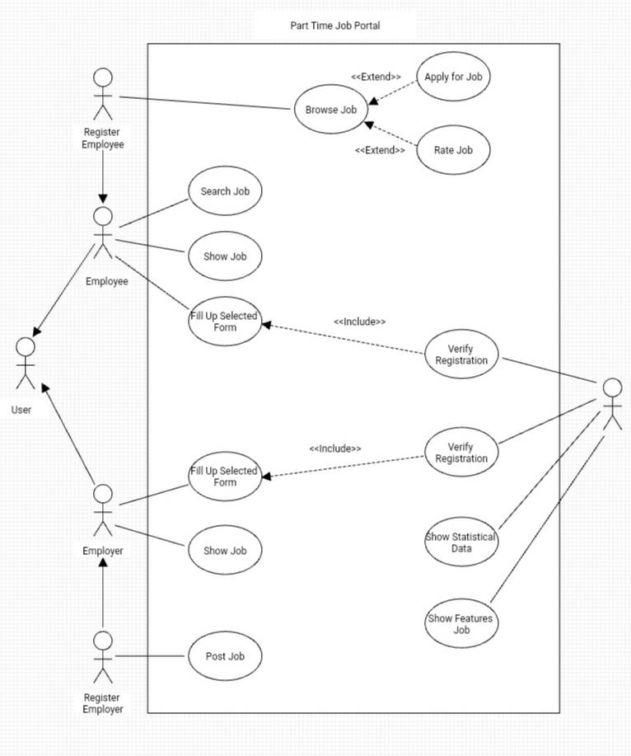

In our Job portal system, there will be two types of users

* Employer
* Employee

However, anyone can visit the page. if anyone wants to apply for a new job or make a new post for the job than he needs to fill up the registration from and this form will be verified by the system. After successful verification they will become registered employee and employer. Registered employees can additionally rate the job.

The system will show the statistical data and also the featured data in the homepage of the portal. All of the verification process will be done by the system.

### ER Diagram

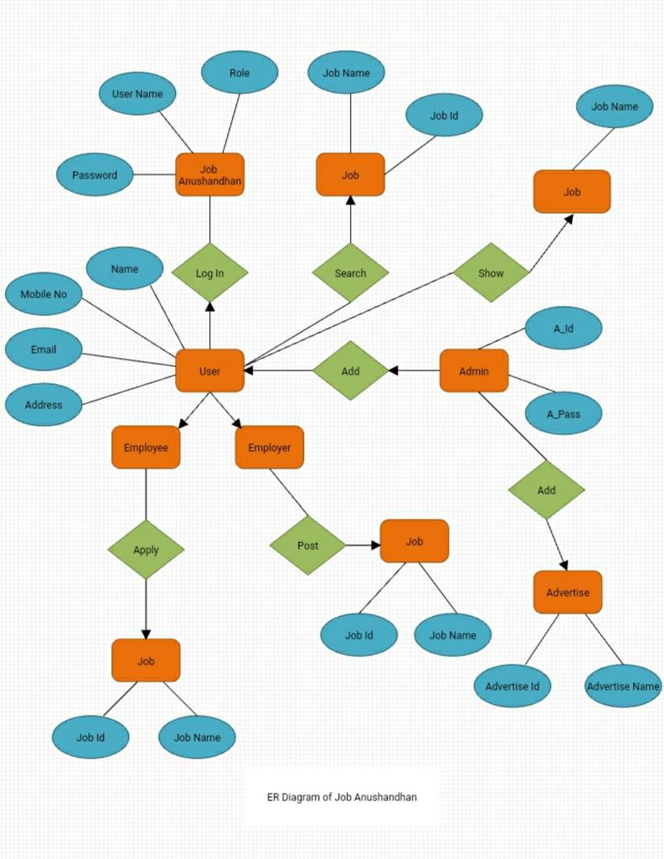

So, In Entity Relationship Diagram Here we used some functionalities like User can complete their registration in the System, use their Username, Email, Password and Role. And log in to the system with their username and Password. User can see the Job and also search the job without logging in to the main website. If any user wants to log in, then all details will be verified by the System admin. After Registering the Employer can Post the job and it will be stored in the database using the job id. Employees can apply for the job and the details will be stored in the database using job id and job name. Here admin have their own password and Name to enter the system.

### Class Diagram

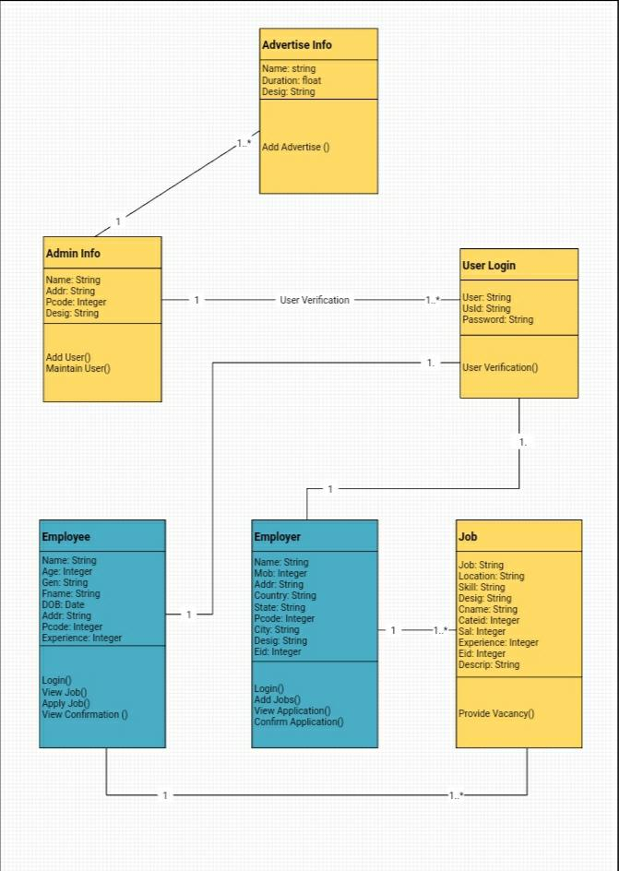

The class diagram describes the entire module of the system. Using this very class diagram, the implementation is completed. The diagram consists of five classes:

* Admin info
* Advertise info
* User login
* Employer
* Employee
* Job

Admin have a name, password. Admin users can both add and maintain users. Advertise can have name, company and number. Admin and advertise have a one-to-many relationships which means that one admin can create multiple advertisement. Employee is one more class in this system which has the following variables: name, age, gender, address, date of birth, experience. Employees can view, apply for and rate the job. Employee class has one-to-one relationship with user as one user can be employed in only one job. The user has only one feature: logging in. Employer is the very last class. They can have name, address, gender and date of birth. Employer also has one-to-one relationship with user for the same reason.

### Activity Diagram

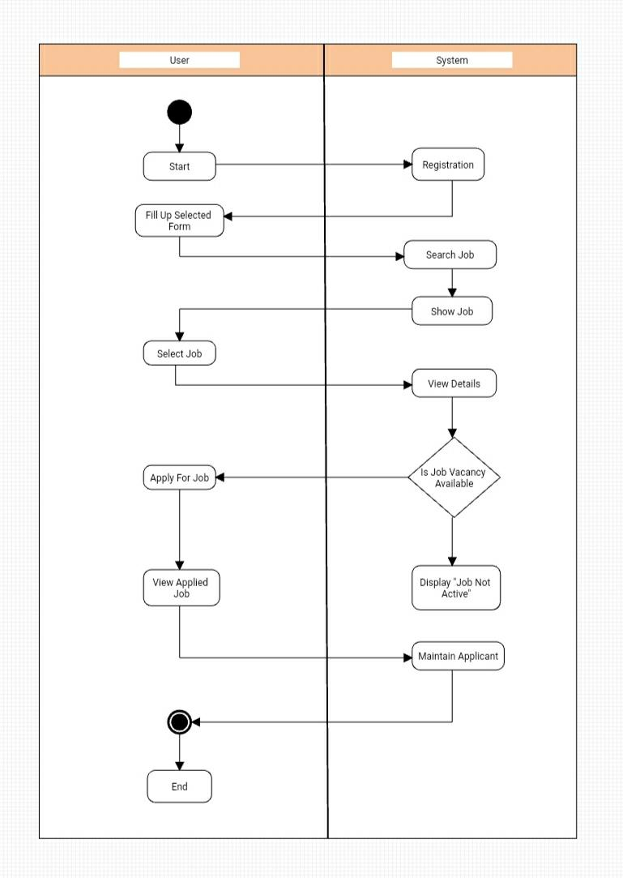

## Data Dictionary

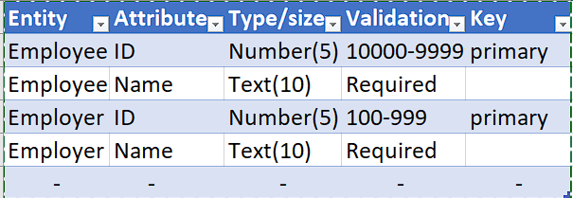

## UI/UX Design Specification

* **Prototype of the Design**



